IPCC Reports and City Climate Change Plans: Proof of concept prototype - Open Climate Reader
FSCI Hackathon Team
8/4/23
Table of contents

1. About the prototype
The prototype is a tool for creating ‘Readers’ made from collated content from IPCC reports. Users can search IPCC Reports, select the content relevant to their questions and create a reader to share with others.
The prototype shows answers from IPCC Reports to five FAQ questions asked about City Climate Plans - outputted as a multi-format Reader - DOCX, PDF, E-Book, and as sources - all referenced to the orginal content.
Use case: Climate plan authors need to find IPCC Report recommendations, sections, visualisations, and external references and use these in their own city climate plans as well as to distribute the content to their community for the purpose of making them democratically — understandable, accountable, and transparent.
Read about the next steps, workflows, and technologies.
- Next prototype #2: Automate Reader creation
- Next prototype #3: AI assisted authoring
semanticClimate is looking for support for the protoytpe rounds - contact semanticClimate on the GitHub discussion thread.
The prototype was made during the semanticClimate hackathon held at the FORCE11 Scholarly Communications Institute (FSCI) - 2023 Summer School - July 31 - August 4 2023.

1.0.1 Prototype questions
Hackathon participants created five questions that are common to City Climate Plans.
Ahead of technically automating the search the mock-up prototype Reader shows the types of examples search results that could be collates.

1.0.1.1 Questions
- Q1. What measures can be taken by urban centers to mitigate and cut down on their emissions?
- Q2. What role do renewable energy sources play in city climate plans?
- Q3. How can cities promote sustainable transportation options in their climate action plans?
- Q4. What strategies do cities employ to adapt to the impacts of climate change?
- Q5. What are some successful examples of cities implementing effective climate action plans?

1.0.2 Background
The IPCC Reports are the source for the most important scientific knowledge on climate change.
City climate plans are important tools to help mitigate the impacts of climate change.
Currently IPCC reports are not supported by search services that allow for granular indexing. The semanticClimate research project uses Linked Open Data (LOD) and Wikidata / Wikibase technologies to enable better visibility for the IPCC Report contents.

1.0.3 Links
- semanticClimate project
- About the hackathon
- More about the City Climate Plan Prototype
- FSCI Summer School 2023

1.0.4 Credits
- See README.md

2. Q1. Mitigation & Cutting Emmisions?

2.1 Question: What measures can be taken by urban centers to mitigate and cut down on their emissions?

2.2 Query result: Climate Change 2022: Mitigation of Climate Change. Chapter 8 : Urban Systems and Other Settlements
Chapter 8 Urban Systems and Other Settlements. In IPCC, 2022: Climate Change 2022: Mitigation of Climate Change. Contribution of Working Group III to the 6th Assessment Report of the IPCC
URL: https://www.ipcc.ch/report/ar6/wg3/
This chapter should be cited as : Lwasa, S., K.C. Seto, X. Bai, H. Blanco, K.R. Gurney, Ş. Kılkış, O. Lucon, J. Murakami, J. Pan, A. Sharifi, Y. Yamagata, 2022: Urban systems and other settlements. In IPCC, 2022: Climate Change 2022: Mitigation of Climate Change. Contribution of Working Group III to the Sixth Assessment Report of the Intergovernmental Panel on Climate Change [P.R. Shukla, J. Skea, R. Slade, A. Al Khourdajie, R. van Diemen, D. McCollum, M. Pathak, S. Some, P. Vyas, R. Fradera, M. Belkacemi, A. Hasija, G. Lisboa, S. Luz, J. Malley, (eds.)]. Cambridge University Press, Cambridge, UK and New York, NY, USA.

2.3 Content:

2.3.1 Chapter 08 : Urban Systems and Other Settlements

2.3.1.1 Executive Summary
Although urbanisation is a global trend often associated with increased incomes and higher consumption, the growing concentration of people and activities is an opportunity to increase resource efficiency and decarbonise at scale (very high confidence). The same urbanisation level can have large variations in per capita urban carbon emissions. For most regions, per capita urban emissions are lower than per capita national emissions. {8.1.4, 8.3.3, 8.4, Box 8.1}
Most future urban population growth will occur in developing countries, where per capita emissions are currently low but expected to increase with the construction and use of new infrastructure and the built environment, and changes in incomes and lifestyles (very high confidence). The drivers of urban greenhouse gas (GHG) emissions are complex and include an interplay of population size, income, state of urbanisation, and how cities are laid out (i.e. urban form). How new cities and towns are designed, constructed, managed, and powered will lock-in behaviour, lifestyles, and future urban GHG emissions. Low-emission urbanisation can improve well-being while minimising impact on GHG emissions, but there is risk that urbanisation can lead to increased global GHG emissions through increased emissions outside the city’s boundaries. {8.1.4, 8.3, Box 8.1, 8.4, 8.6}
The urban share of global GHG emissions (including carbon dioxide (CO2) and methane (CH4)) is substantive and continues to increase (high confidence). In 2015, urban emissions were estimated to be 25 GtCO2-eq (about 62% of the global share) and in 2020, 29 GtCO2-eq (67–72% of the global share).1 About 100 of the highest emitting urban areas account for approximately 18% of the global carbon footprint. {8.1.6, 8.3.3}
The urban share of regional GHG emissions increased between 2000 and 2015, with much inter-region variation in the magnitude of the increase (high confidence). Globally, the urban share of national emissions increased 6 percentage points, from 56% in 2000 to 62% in 2015. For 2000 to 2015, the urban emissions share across AR6 WGIII regions increased from 28% to 38% in Africa, from 46% to 54% in Asia and Pacific, from 62% to 72% in Developed Countries, from 57% to 62% in Eastern Europe and West-Central Asia, from 55% to 66% in Latin America and Caribbean, and from 68% to 69% in the Middle East. {8.1.6, 8.3.3}
Per capita urban GHG emissions increased between 2000 and 2015, with cities in the Developed Countries region producing nearly seven times more per capita than the lowest emitting region (medium confidence). From 2000 to 2015, global urban GHG emissions per capita increased from 5.5 to 6.2 tCO2-eq per person (an increase of 11.8%); Africa increased from 1.3 to 1.5 tCO2-eq per person (22.6%); Asia and Pacific increased from 3.0 to 5.1 tCO2-eq per person (71.7%); Eastern Europe and West-Central Asia increased from 6.9 to 9.8 tCO2-eq per person (40.9%); Latin America and Caribbean increased from 2.7 to 3.7 tCO2-eq per person (40.4%); and Middle East increased from 7.4 to 9.6 tCO2-eq per person (30.1%). Albeit starting from the highest level, Developed Countries had a decline of 11.4 to 10.7 tCO2-eq per person (–6.5%). {8.3.3}
The global share of future urban GHG emissions is expected to increase through 2050, with moderate to low mitigation efforts, due to growth trends in population, urban land expansion, and infrastructure and service demands, but the extent of the increase depends on the scenario and the scale and timing of urban mitigation action (medium confidence). In modelled scenarios, global consumption-based urban CO2 and CH4 emissions are projected to rise from 29 GtCO2-eq in 2020 to 34 GtCO2-eq in 2050 with moderate mitigation efforts (intermediate GHG emissions, SSP2–4.5), and up to 40 GtCO2-eq in 2050 with low mitigation efforts (high GHG emissions, SSP3–7.0).
Urban land areas could triple between 2015 and 2050, with significant implications for future carbon lock-in. There is a large range in the forecasts of urban land expansion across scenarios and models, which highlights an opportunity to shape future urban development towards low- or net-zero GHG emissions and minimise the loss of carbon stocks and sequestration in the agriculture, forestry and other land use (AFOLU) sector due to urban land conversion (medium confidence). By 2050, urban areas could increase up to 211% over the 2015 global urban extent, with the median projected increase ranging from 43% to 106%. While the largest absolute amount of new urban land is forecasted to occur in Asia and Pacific, and in Developed Countries, the highest rate of urban land growth is projected to occur in Africa, Eastern Europe and West-Central Asia, and in the Middle East. The infrastructure that will be constructed concomitant with urban land expansion will lock-in patterns of energy consumption that will persist for decades if not generations. Furthermore, given past trends, the expansion of urban areas is likely to take place on agricultural lands and forests, with implications for the loss of carbon stocks and sequestration. {8.3.1, 8.3.4, 8.4.1, 8.6}
The construction of new, and upgrading of, existing urban infrastructure through 2030 will result in significant emissions (very high confidence). The construction of new and upgrading of existing urban infrastructure using conventional practices and technologies can result in significant committed CO2 emissions, ranging from 8.5 GtCO2 to 14 GtCO2 annually up to 2030 and more than double annual resource requirements for raw materials to about 90 billion tonnes per year by 2050, up from 40 billion tonnes in 2010 (medium evidence, high agreement). {8.4.1, 8.6}
Given the dual challenges of rising urban GHG emissions and future projections of more frequent extreme climate events, there is an urgent need to integrate urban mitigation and adaptation strategies for cities to address climate change and withstand its effects (very high confidence). Mitigation strategies can enhance resilience against climate change impacts while contributing to social equity, public health, and human wellbeing. Urban mitigation actions that facilitate economic decoupling can have positive impacts on employment and local economic competitiveness. {8.2, Cross-Working Group Box 2, 8.4}
Cities can only achieve net-zero GHG emissions through deep decarbonisation and systemic transformation (very high confidence). Three broad mitigation strategies have been found to be effective in reducing emissions when implemented concurrently: (i) reducing or changing urban energy and material use towards more sustainable production and consumption across all sectors, including through compact and efficient urban forms and supporting infrastructure; (ii) electrification and switching to net-zero-emissions resources; and (iii) enhancing carbon uptake and storage in the urban environment (high evidence, high agreement). Given the regional and global reach of urban supply chains, cities can achieve net-zero emissions only if emissions are reduced within and outside of their administrative boundaries. {8.1.6, 8.3.4, 8.4, 8.6}
Packages of mitigation policies that implement multiple urbanscale interventions can have cascading effects across sectors, reduce GHG emissions outside of a city’s administrative boundaries, and reduce more emissions than the net sum of individual interventions, particularly if multiple scales of governance are included (high confidence). Cities have the ability to implement policy packages across sectors using an urban systems approach, especially those that affect key infrastructure based on spatial planning, electrification of the urban energy system, and urban green and blue infrastructure. The institutional capacity of cities to develop, coordinate, and integrate sectoral mitigation strategies within their jurisdiction varies by context, particularly those related to governance, the regulatory system, and budgetary control. {8.4, 8.5, 8.6}
Integrated spatial planning to achieve compact and resourceefficient urban growth through co-location of higher residential and job densities, mixed land use, and transit-oriented development (TOD) could reduce GHG emissions between 23% and 26% by 2050 compared to the business-as-usual scenario (robust evidence, high agreement, very high confidence). Compact cities with shortened distances between housing and jobs, and interventions that support a modal shift away from private motor vehicles towards walking, cycling, and low-emissions shared and public transportation, passive energy comfort in buildings, and urban green infrastructure can deliver significant public health benefits and have lower GHG emissions. {8.2, 8.3.4, 8.4, 8.6}
Urban green and blue infrastructure can mitigate climate change through carbon sequestration, avoided emissions, and reduced energy use while offering multiple co-benefits (robust evidence, high agreement). Urban green and blue infrastructure, including urban forests and street trees, permeable surfaces, and green roofs3 offer potential to mitigate climate change directly through sequestering and storing carbon, and indirectly by inducing a cooling effect that reduces energy demand and reducing energy use for water treatment. Global urban trees store approximately 7.4 billion tonnes of carbon, and sequester approximately 217 million tonnes of carbon annually, although urban tree carbon storage and sequestration are highly dependent on biome. Among the multiple co-benefits of green and blue infrastructure are reducing the urban heat island (UHI) effect and heat stress, reducing stormwater runoff, improving air quality, and improving mental and physical health of urban dwellers. {8.2, 8.4.4}
The potential and sequencing of mitigation strategies to reduce GHG emissions will vary depending on a city’s land use, spatial form, development level, and state of urbanisation i.e., whether it is an established city with existing infrastructure, a rapidly growing city with new infrastructure, or an emerging city with infrastructure buildup (high confidence). New and emerging cities will have significant infrastructure development needs to achieve high quality of life, which can be met through energyefficient infrastructures and services, and people-centred urban design (high confidence). The long lifespan of urban infrastructures locks in behaviour and committed emissions. Urban infrastructures and urban form can enable socio-cultural and lifestyle changes that can significantly reduce carbon footprints. Rapidly growing cities can avoid higher future emissions through urban planning to co-locate jobs and housing to achieve compact urban form, and by leapfrogging to low-carbon technologies. Established cities will achieve the largest GHG emissions savings by replacing, repurposing, or retrofitting the building stock, targeted infilling and densifying, as well as through modal shift and the electrification of the urban energy system. New and emerging cities have unparalleled potential to become low or net-zero GHG emissions while achieving high quality of life by creating compact, co-located, and walkable urban areas with mixed land use and transit-oriented design, that also preserve existing green and blue assets. {8.2, 8.4, 8.6}
With over 880 million people living in informal settlements, there are opportunities to harness and enable informal practices and institutions in cities related to housing, waste, energy, water, and sanitation to reduce resource use and mitigate climate change (low evidence, medium agreement). The upgrading of informal settlements and inadequate housing to improve resilience and well-being offers a chance to create a lowcarbon transition. However, there is limited quantifiable data on these practices and their cumulative impacts on GHG emissions. {8.1.4, 8.2.2, Cross-Working Group Box 2, 8.3.2, 8.4, 8.6, 8.7}
Achieving transformational changes in cities for climate change mitigation and adaptation will require engaging multiple scales of governance, including governments and non-state actors, and in connection with substantive financing beyond sectoral approaches (very high confidence). Large and complex infrastructure projects for urban mitigation are often beyond the capacity of local municipality budgets, jurisdictions, and institutions. Partnerships between cities and international institutions, national and regional governments, transnational networks, and local stakeholders play a pivotal role in mobilising global climate finance resources for a range of infrastructure projects with lowcarbon emissions and related spatial planning programmes across key sectors. {8.4, 8.5}

2.3.2 Footnotes
1 These estimates are based on consumption-based accounting, including both direct emissions from within urban areas, and indirect emissions from outside urban areas related to the production of electricity, goods, and services consumed in cities. Estimates include all CO2 and CH4 emission categories except for aviation and marine bunker fuels, land-use change, forestry, and agriculture. {8.1, Annex I: Glossary}
2 These scenarios have been assessed by WGI to correspond to intermediate, high, and very low GHG emissions.
3 These examples are considered to be a subset of nature-based solutions or ecosystem-based approaches.

3. Q2. Renewable energy?

3.1 Question: What role do renewable energy sources play in city climate plans?

3.2 Query result: Box 6.8 | 100% Renewables in Net-zero Energy Systems (Page 675-676)
Chapter 6 Energy Systems. In IPCC, 2022: Climate Change 2022: Mitigation of Climate Change. Contribution of Working Group III to the 6th Assessment Report of the IPCC
URL: https://www.ipcc.ch/report/ar6/wg3/
Cite: Clarke, L., Y.-M. Wei, A. De La Vega Navarro, A. Garg, A.N. Hahmann, S. Khennas, I.M.L. Azevedo, A. Löschel, A.K. Singh, L. Steg, G. Strbac, K. Wada, 2022: Energy Systems. In IPCC, 2022: Climate Change 2022: Mitigation of Climate Change. Contribution of Working Group III to the Sixth Assessment Report of the Intergovernmental Panel on Climate Change [P.R. Shukla, J. Skea, R. Slade, A. Al Khourdajie, R. van Diemen, D. McCollum, M. Pathak, S. Some, P. Vyas, R. Fradera, M. Belkacemi, A. Hasija, G. Lisboa, S. Luz, J. Malley, (eds.)]. Cambridge University Press, Cambridge, UK and New York, NY, USA. doi: 10.1017/9781009157926.008.

3.3 Content:

3.3.1 Box 6.8 | 100% Renewables in Net-zero Energy Systems
The decreasing cost and increasing performance of renewable energy has generated interest in the feasibility of providing nearly all energy services with renewables. Renewable energy includes wind power, solar power, hydroelectric power, bioenergy, geothermal energy, tidal power, and ocean power. There are two primary frames around which 100% renewable energy systems are discussed: 100% renewable electricity systems and 100% renewable energy systems, considering not only electricity but all aspects of the energy system.
It is technically feasible to use very high renewable shares (e.g., above 75% of annual regional generation) to meet hourly electricity demand under a range of conditions, especially when VRE options, notably wind and solar, are complemented by other resources (high confidence). There are currently many grids with high renewable shares and large anticipated roles for VRE sources, in particular wind and solar (Section 6.4), in future low-carbon electricity systems. An increasingly large set of studies examines the feasibility of high renewable penetration and economic drivers under different policy, technology, and market scenarios (Cochran et al. 2014; Deason 2018; Jenkins et al. 2018b; Bistline et al. 2019; Hansen et al. 2019; Dowling et al. 2020; Blanford et al. 2021; Denholm et al. 2021). High wind and solar penetration involves technical and economic challenges due to their unique characteristics such as spatial and temporal variability, short- and long-term uncertainty, and non-synchronous generation (Cole et al. 2017). These challenges become increasingly important as renewable shares approach 100% (Sections 6.6.2.2 and 6.4.3).
There are many balancing options in systems with very high renewables (Milligan et al. 2015; Jenkins et al. 2018b; Mai et al. 2018; Bistline 2021a; Denholm et al. 2021).
- Energy storage. Energy storage technologies like batteries, pumped hydro, and hydrogen can provide a range of system services (Balducci et al. 2018; Bistline et al. 2020a) (Section 6.4.4). Lithium-ion batteries have received attention as costs fall and installations increase, but very high renewable shares typically entail either dispatchable generation or long-duration storage in addition to short-duration options (Jenkins et al. 2018b; Arbabzadeh et al. 2019; Schill 2020). Energy storage technologies are part of a broad set of options (including synchronous condensers, demand-side measures, and even inverter-based technologies themselves) for providing grid services (Castillo and Gayme 2014; EPRI 2019a).
- Transmission and trade. To balance differences in resource availability, high renewable systems will very likely entail investments in transmission capacity (Mai et al. 2014; Macdonald et al. 2016; Pleßmann and Blechinger 2017; Zappa et al. 2019) (Section 6.4.5) and changes in trade (Abrell and Rausch 2016; Bistline et al. 2019). These increases will likely be accompanied by expanded balancing regions to take advantage of geographical smoothing.
- Dispatchable (‘on-demand’) generation. Dispatchable generation could include flexible fossil units or low-carbon fuels such as hydrogen with lower minimum load levels (Denholm et al. 2018; Bistline 2019), renewables like hydropower, geothermal, or biomass (Hirth 2016; Hansen et al. 2019), or flexible nuclear (Jenkins et al. 2018a). The composition depends on costs and other policy goals, though in all cases, capacity factors are low for these resources (Mills et al. 2020).
- Demand management: Many low-emitting and high-renewables systems also utilise increased load flexibility in the forms of energy efficiency, demand response, and demand flexibility, utilising newly electrified end uses such as electric vehicles to shape demand profiles to better match supply (Ameli et al. 2017; Hale 2017; Brown et al. 2018; Imelda et al. 2018a; Bistline 2021a). • Sector coupling: Sector coupling includes increased end-use electrification and PtX electricity conversion pathways, which may entail using electricity to create synthetic fuels such as hydrogen (Davis et al. 2018; Ueckerdt et al. 2021) (Sections 6.4.3, 6.4., 6.4.5, 6.6.4.3, and 6.6.4.6).
Deployment of integration options depends on their relative costs and value, regulations, and electricity market design. There is considerable uncertainty about future technology costs, performance, availability, scalability, and public acceptance (Kondziella and Bruckner 2016; Bistline et al. 2019). Deploying balanced resources likely requires operational, market design, and other institutional changes, as well as technological changes in some cases (Denholm et al. 2021; Cochran et al. 2014). Mixes will differ based on resources, system size, flexibility, and whether grids are isolated or interconnected.
Although there are no technical upper bounds on renewable electricity penetration, the economic value of additional wind and solar capacity typically decreases as their penetration rises, creating economic challenges at higher deployment levels (Hirth 2013; Gowrisankaran et al. 2016; Cole et al. 2021; Denholm et al. 2021; Millstein et al. 2021). The integration options above, as well as changes to market design, can mitigate these challenges but likely will not solve them, especially since these options can exhibit declining value themselves (De Sisternes et al. 2016; Bistline 2017; Denholm and Mai 2019) and may be complements or substitutes to each other.
Energy systems that are 100% renewable (including all parts of the energy sector, and not only electricity generation) raise a range of technological, regulatory, market, and operational challenges that make their competitiveness uncertain (high confidence). These systems require decarbonising all electricity, using this zero-carbon electricity broadly, and then utilising zero-carbon energy carriers for all end uses not served by electricity, for example, air travel, long-distance transport, and high-temperature process heat. Broader questions emerge regarding the attractiveness of supplying all energy, and not just electricity, with renewables (Figure 6.22). Integrated assessment and energy systems research suggest large roles for renewables, but energy and electricity shares are far from 100%, even with stringent emissions reductions targets and optimistic assumptions about future cost reductions (Bauer et al. 2018; Bistline et al. 2018; Jenkins et al. 2018b; Huntington et al. 2020) (Section 6.7.1). Scenarios with 100% renewable energy systems are an emerging subset in the decarbonisation literature, especially at regional levels (Hansen et al. 2019; Denholm et al. 2021). Many 100% renewables studies focus more heavily on electrification for decarbonising end uses, and include less biofuels and hydrogen than the broader literature on deep decarbonisation (Bauer et al. 2018a). These studies typically assume a constrained set of available technologies to demonstrate the technical feasibility of very high renewable systems and do not optimise to find least-cost, technology-neutral decarbonisation pathways, and many 100% renewables studies focus on the electricity sector or a limited number of sectors (Jenkins et al. 2018a; Hansen et al. 2019). In addition to renewables, studies broadly agree that including additional lowcarbon options – including not only low-carbon electricity but also targeted use of fossil fuels with and without CCS (Section 6.6.2.1) and alternative fuels for sectors that are difficult to electrify (Section 6.6.2.4) – can lower the cost of decarbonisation, even with very high shares of renewables (Figure 6.22). However, there is disagreement about the magnitude of cost savings from larger portfolios, which depend on context- and scenario-specific assumptions about technologies, markets, and policies.

4. Q3. Sustainable Transport Options?

4.1 Question: How can cities promote sustainable transportation options in their climate action plans?

4.2 Query result: 10.7.4 Transport Modes Trajectories (Page 1104-1106)
Chapter 10 Transport. In IPCC, 2022: Climate Change 2022: Mitigation of Climate Change. Contribution of Working Group III to the 6th Assessment Report of the IPCC
URL: https://www.ipcc.ch/report/ar6/wg3/
Cite: Jaramillo, P., S. Kahn Ribeiro, P. Newman, S. Dhar, O.E. Diemuodeke, T. Kajino, D.S. Lee, S.B. Nugroho, X. Ou, A. Hammer Strømman, J. Whitehead, 2022: Transport. In IPCC, 2022: Climate Change 2022: Mitigation of Climate Change. Contribution of Working Group III to the Sixth Assessment Report of the Intergovernmental Panel on Climate Change [P.R. Shukla, J. Skea, R. Slade, A. Al Khourdajie, R. van Diemen, D. McCollum, M. Pathak, S. Some, P. Vyas, R. Fradera, M. Belkacemi, A. Hasija, G. Lisboa, S. Luz, J. Malley, (eds.)]. Cambridge University Press, Cambridge, UK and New York, NY, USA. doi: 10.1017/9781009157926.012

4.3 Content:

4.3.1 10.7.4 Transport Modes Trajectories
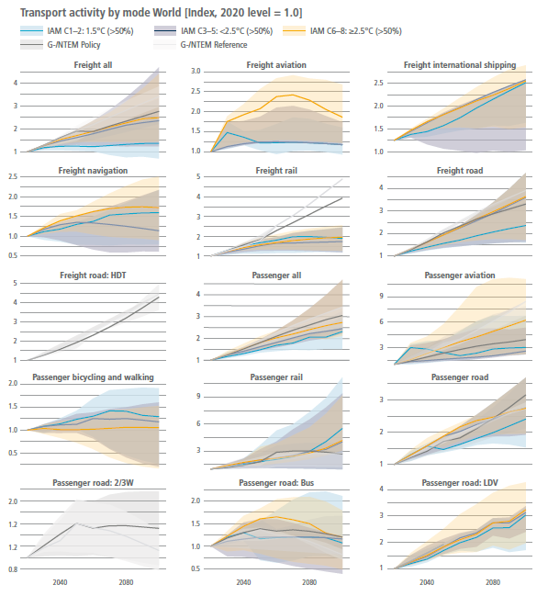
Figure 10.19 | Transport activity trajectories for passenger and freight across different modes. Global passenger (billion pkm per year) and freight (billion tkm per year) demand projections relative to a modelled year 2020 index. Results for IAM are for selected stabilisation temperatures by 2100. Also included are global transport models Reference and Policy scenarios. Data from the AR6 scenario database. Trajectories span the 5th to 95th percentiles across models, with a solid line indicating the median value across models.
Globally over the last century, shares of faster transport modes have generally increased with increasing passenger travel demand (Schäfer 2017; Schafer and Victor 2000). For short- to medium-distance travel, private cars have displaced public transit, particularly in OECD countries, due to a variety of factors, including faster travel times in many circumstances (Liao et al. 2020); consumers increasingly valuing time and convenience with GDP growth; and broader transport policies, such as provision of road versus public transit infrastructure (Mattioli et al. 2020). For long-distance travel, travel via aviation for leisure and business has increased (Lee et al. 2021). These trends do not hold in all countries and cities, as many now have rail transit that is faster than driving (Newman et al. 2015). For instance, public transport demand rose from 1990 through to 2016 in France, Denmark, and Finland (eurostat 2019). In general, smaller and denser countries and cities with higher or increasing urbanisation rates tend to have greater success in increasing public transport share. However, other factors, like privatisation of public transit (Bayliss and Mattioli 2018) and urban form (ITF 2021), also play a role. Different transport modes can provide passenger and freight services, affecting the emissions trajectories for the sector.
Figure 10.19 shows activity trajectories for freight and passenger transport through 2100 relative to a modelled year 2020 across different modes, based on the AR6 database for IAMs and global transport models. Globally, climate scenarios from IAMs, and policy and reference scenarios from global transport models, indicate increasing demand for freight and passenger transport via most modes through 2100 (Yeh et al. 2017; Mulholland et al. 2018; Zhang et al. 2018; Khalili et al. 2019). Road passenger transport exhibits a similar increase (roughly tripling) through 2100 across scenarios. For road passenger transport, scenarios that limit or return warming to 1.5°C during the 21st century (C1–C2) have a smaller increase from modelled 2020 levels (median increase of 2.4 times modelled 2020 levels) than do scenarios with higher warming levels (C3–C8) (median increase of 2.7–2.8 times modelled 2020 levels). There are similar patterns for passenger road transport via light-duty vehicle, for which median increases from modelled 2020 levels are smaller for C1–C2 (3 times larger) than for C3–C5 (3.1 times larger) or C6–C7 (3.2 times larger). Passenger transport via aviation exhibits a 2.2 times median increase relative to modelled 2020 levels under C1–C2 and C3–C5 scenarios but exhibits a 6.2 times increase under C6–C8. The only passenger travel mode that exhibits a decline in its median value through 2100 according to IAMs is walking/bicycling, in C3– C5 and C6–C8 scenarios. However, in C1–C2 scenarios, walking/ bicycling increases by 1.4 times relative to modelled 2020 levels. At the 5th percentile of IAM solutions (lower edge of bands in Figure 10.19), buses and walking/bicycling for passenger travel both exhibit significant declines.
For freight, Figure 10.19 shows that the largest growth occurs in transport via road (Mulholland et al. 2018). By 2100, global transport models suggest a roughly four-fold increase in median-heavy-duty trucking levels relative to modelled 2020 levels, while IAMs suggest a two- to four-fold increase in freight transport by road by 2100. Notably, the 95th percentile of IAM solutions see road transport by up to 4.7 times through 2100 relative to modelled 2020 levels, regardless of warming level. Other freight transport modes – aviation, international shipping, navigation, and railways – exhibit less growth than road transport. In scenarios that limit or return warming to 1.5°C (>50%) during the 21st century (C1–C2), navigation and rail transport remain largely unchanged and international shipping roughly doubles by 2100. Scenarios with higher warming (i.e., moving from C1–C2 to C6–C8) generally lead to more freight by rail and less freight by international shipping.
Relative to global trajectories, upper-income regions – including North America, Europe, and the Pacific OECD – generally see less growth in passenger road via light-duty vehicle and passenger aviation, given more saturated demand for both. Other regions like China exhibit similar modal trends as the global average, whereas regions such as the African continent and Indian subcontinent exhibit significantly larger shifts, proportionally, in modal transport than the globe. In particular, the African continent represents the starkest departure from global results. Freight and passenger transport modes exhibit significantly greater growth across Africa than globally in all available scenarios. Across Africa, median freight and passenger transport via road from IAMs increases by 5 to 16 times and 4 to 28 times, respectively, across warming levels by 2100 relative to modelled 2020 levels. Even C1 has considerable growth in Africa via both modes (3 to 16 times increase for freight and 4 to 29 times increase for passenger travel at 5th and 95th percentiles of IAM solutions by 2100).
As noted in Section 10.2, commonly explored mitigation options related to mode change include a shift to public transit, shared mobility, and demand reductions through various means, including improved urban form, teleconferences that replace passenger travel (Creutzig et al. 2018; Grubler et al. 2018; Wilson et al. 2019), improved logistics efficiency, green logistics, and streamlined supply chains for the freight sector (Mulholland et al. 2018). NDCs often prioritise options like bus improvements and enhanced mobility that yield pollution, congestion, and urban development co-benefits, especially in medium- and lower-income countries (Fulton et al. 2017). Conversely, high-income countries, most of which have saturated and entrenched private vehicle ownership, typically focus more on technology options, such as electrification and fuel efficiency standards (Gota et al. 2016). Available IAM and regional models are limited in their ability to represent modal shift strategies. As a result, mode shifts alone do not differentiate climate scenarios. While this lack of representation is a limitation of the models, it is unlikely that such interventions would completely negate the increases in demand the models suggest. Therefore, transport via light-duty vehicle and aviation, freight transport via road, and other modes will likely continue to increase through to the end of the century. Consequently, fuel and carbon efficiency and fuel energy and technology will probably play crucial roles in differentiating climate scenarios, as discussed in the following sub-sections.

5. Q4. Adapting to Impacts?

5.1 Question: What strategies do cities employ to adapt to the impacts of climate change?

5.2 Query result: 4.5.3. Cities, Settlements and Infrastructure (Page 105-106)
IPCC, 2023: Climate Change 2023: Synthesis Report. Section 4: Near-Term Responses in a Changing Climate > 4.5 Near-Term Mitigation and Adaptation Actions > 4.5.3 Cities, Settlements and Infrastructure
URL: https://www.ipcc.ch/report/ar6/syr/
Cite: IPCC, 2023: Climate Change 2023: Synthesis Report. Contribution of Working Groups I, II and III to the Sixth Assessment Report of the Intergovernmental Panel on Climate Change [Core Writing Team, H. Lee and J. Romero (eds.)]. IPCC, Geneva, Switzerland, 184 pp., doi: 10.59327/IPCC/AR6-9789291691647.

5.3 Content:

5.3.1 4.5.3. Cities, Settlements and Infrastructure
Urban systems are critical for achieving deep emissions reductions and advancing climate resilient development, particularly when this involves integrated planning that incorporates physical, natural and social infrastructure (high confidence). Deep emissions reductions and integrated adaptation actions are advanced by: integrated, inclusive land use planning and decision-making; compact urban form by co-locating jobs and housing; reducing or changing urban energy and material consumption; electrification in combination with low emissions sources; improved water and waste management infrastructure; and enhancing carbon uptake and storage in the urban environment (e.g. bio-based building materials, permeable surfaces and urban green and blue infrastructure). Cities can achieve net zero emissions if emissions are reduced within and outside of their administrative boundaries through supply chains, creating beneficial cascading effects across other sectors. (high confidence) {WGII SPM C.5.6, WGII SPM D.1.3, WGII SPM D.3; WGIII SPM C.6, WGIII SPM C.6.2, WGIII TS 5.4, SR1.5 SPM C.2.4}
Considering climate change impacts and risks (e.g., through climate services) in the design and planning of urban and rural settlements and infrastructure is critical for resilience and enhancing human well-being. Effective mitigation can be advanced at each of the design, construction, retrofit, use and disposal stages for buildings. Mitigation interventions for buildings include: at the construction phase, low-emission construction materials, highly efficient building envelope and the integration of renewable energy solutions; at the use phase, highly efficient appliances/equipment, the optimisation of the use of buildings and their supply with low-emission energy sources; and at the disposal phase, recycling and re-using construction materials. Sufficiency155 measures can limit the demand for energy and materials over the lifecycle of buildings and appliances. (high confidence) {WGII SPM C.2.5; WGIII SPM C.7.2}
Transport-related GHG emissions can be reduced by demand-side options and low-GHG emissions technologies. Changes in urban form, reallocation of street space for cycling and walking, digitalisation (e.g., teleworking) and programs that encourage changes in consumer behaviour (e.g. transport, pricing) can reduce demand for transport services and support the shift to more energy efficient transport modes (high confidence). Electric vehicles powered by low-emissions electricity offer the largest decarbonisation potential for land-based transport, on a life cycle basis (high confidence). Costs of electrified vehicles are decreasing and their adoption is accelerating, but they require continued investments in supporting infrastructure to increase scale of deployment (high confidence). The environmental footprint of battery production and growing concerns about critical minerals can be addressed by material and supply diversification strategies, energy and material efficiency improvements, and circular material flows (medium confidence). Advances in battery technologies could facilitate the electrification of heavy-duty trucks and compliment conventional electric rail systems (medium confidence). Sustainable biofuels can offer additional mitigation benefits in land-based transport in the short and medium term (medium confidence). Sustainable biofuels, low-emissions hydrogen, and derivatives (including synthetic fuels) can support mitigation of CO2 emissions from shipping, aviation, and heavy-duty land transport but require production process improvements and cost reductions (medium confidence). Key infrastructure systems including sanitation, water, health, transport, communications and energy will be increasingly vulnerable if design standards do not account for changing climate conditions (high confidence). {WGII SPM B.2.5; WGIII SPM C.6.2, WGIII SPM C.8, WGIII SPM C.8.1, WGIII SPM C.8.2, WGIII SPM C.10.2, WGIII SPM C.10.3, WGIII SPM C.10.4}
Green/natural and blue infrastructure such as urban forestry, green roofs, ponds and lakes, and river restoration can mitigate climate change through carbon uptake and storage, avoided emissions, and reduced energy use while reducing risk from extreme events such as heatwaves, heavy precipitation and droughts, and advancing co-benefits for health, well-being and livelihoods (medium confidence). Urban greening can provide local cooling (very high confidence). Combining green/natural and grey/physical infrastructure adaptation responses has potential to reduce adaptation costs and contribute to flood control, sanitation, water resources management, landslide prevention and coastal protection (medium confidence). Globally, more financing is directed at grey/physical infrastructure than green/natural infrastructure and social infrastructure (medium confidence), and there is limited evidence of investment in informal settlements (medium to high confidence). The greatest gains in well-being in urban areas can be achieved by prioritising finance to reduce climate risk for low-income and marginalised communities including people living in informal settlements (high confidence). {WGII SPM C.2.5, WGII SPM C.2.6, WGII SPM C.2.7, WGII SPM D.3.2, WGII TS.E.1.4, WGII Cross-Chapter Box FEAS; WGIII SPM C.6, WGIII SPM C.6.2, WGIII SPM D.1.3, WGIII SPM D.2.1}
Responses to ongoing sea level rise and land subsidence in low-lying coastal cities and settlements and small islands include protection, accommodation, advance and planned relocation. These responses are more effective if combined and/or sequenced, planned well ahead, aligned with sociocultural values and development priorities, and underpinned by inclusive community engagement processes. (high confidence) {WGII SPM C.2.8}

6. Q5. Successful example plans?

6.1 Question: What are some successful examples of cities implementing effective climate action plans?

6.2 Query result: Box 8.3: Coordination of Fragmented Policymaking for Low-carbon Urban Development: Example from Shanghai, China (Page 913)
Chapter 8 Urban Systems and Other Settlements. In IPCC, 2022: Climate Change 2022: Mitigation of Climate Change. Contribution of Working Group III to the 6th Assessment Report of the IPCC
URL: https://www.ipcc.ch/report/ar6/wg3/
Cite: This chapter should be cited as : Lwasa, S., K.C. Seto, X. Bai, H. Blanco, K.R. Gurney, Ş. Kılkış, O. Lucon, J. Murakami, J. Pan, A. Sharifi, Y. Yamagata, 2022: Urban systems and other settlements. In IPCC, 2022: Climate Change 2022: Mitigation of Climate Change. Contribution of Working Group III to the Sixth Assessment Report of the Intergovernmental Panel on Climate Change [P.R. Shukla, J. Skea, R. Slade, A. Al Khourdajie, R. van Diemen, D. McCollum, M. Pathak, S. Some, P. Vyas, R. Fradera, M. Belkacemi, A. Hasija, G. Lisboa, S. Luz, J. Malley, (eds.)]. Cambridge University Press, Cambridge, UK and New York, NY, USA.

6.3 Content:

6.3.1 Chapter 08 : Urban Systems and Other Settlements

6.3.1.1 Box 8.3: Coordination of Fragmented Policymaking for Low-carbon Urban Development: Example from Shanghai, China
As a growing megacity in the Global South, Shanghai represents the challenge of becoming low carbon despite its economic growth and population size (Chen et al. 2017). Shanghai was designated as one of the pilot low-carbon cities by the central government. The city utilised a coordination mechanism for joining fragmented policymaking across the city’s economy, energy, and environment. The coordination mechanism was supported by a direct fund that enabled implementation of cross-sector policies beyond a singlesector focus across multiple institutions while increasing capacity for enabling a low-carbon transition for urban sustainability (Peng and Bai 2020).
Implementation and governance process
In Shanghai, coordination between the central and local governments had an instrumental role for encouraging low-carbon policy experimentation. Using a nested governance framework, the central government provided target setting and performance evaluation while the local government initiated pilot projects for low-carbon development. The policy practices in Shanghai surpassed the topdown targets and annual reporting of GHG emissions, including carbon labelling standards at the local level, pilot programme for transitioning sub-urban areas, and the engagement of public utilities (Peng and Bai 2018).
Towards low-carbon urban development
New policy measures in Shanghai were built upon a series of related policies from earlier, ranging from general energy saving measures to air pollution reduction. This provided a continuum of policy learning for implementing low-carbon policy measures. An earlier policy was a green electricity scheme based on the Jade Electricity Program while the need for greater public awareness was one aspect requiring further attention in policy design (Baeumler et al. 2012), supporting policy-learning for policies later on. The key point here is that low-carbon policies were built on and learned from earlier policies with similar goals.
Outcomes and impacts of the policy mix
Trends during 1998 and 2015 indicate that energy intensity decreased from about 130 tonnes per million RMB to about 45 tonnes per million RMB and carbon intensity decreased from about 0.35 Mt per billion RMB to 0.10 Mt per billion RMB (Peng and Bai 2018). These impacts on energy and carbon intensities represent progress, while challenges remain. Among the challenges are the need for investment in low-carbon technology and increases in urban carbon sinks (Yang and Li 2018) while cross-sector interaction and complexity are increasing.

7. Prototype Next Steps & Workflows
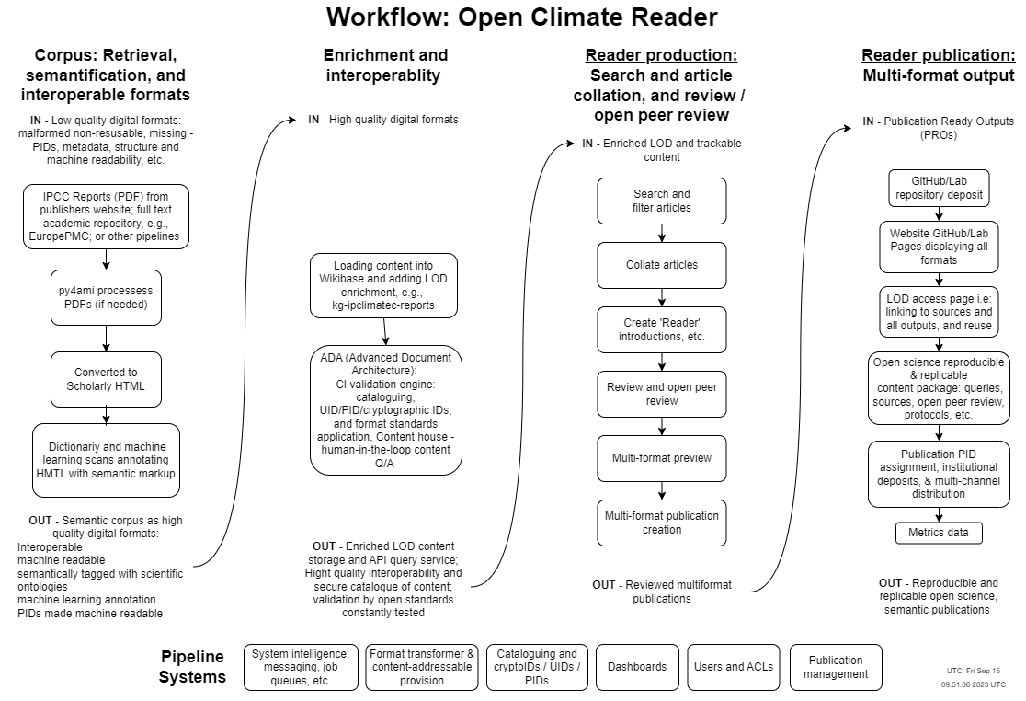
Workflow: City - Open Climate Reader

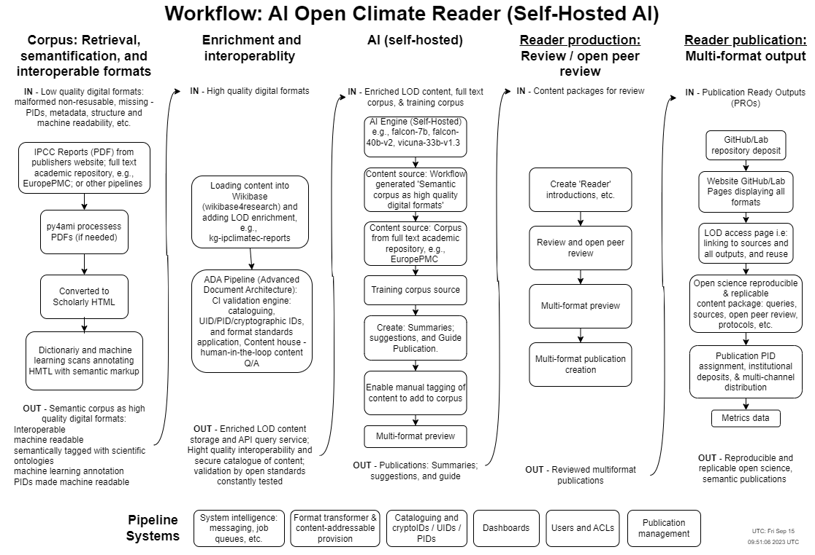
Workflow: AI Open Climate Reader
See diagrams here: https://github.com/semanticClimate/city-open-climate-reader/tree/main/workflows

7.1 Next steps?
If you’re interested in helping out on the next round of prototyping by volunteering or contributing resources check out the semanticClimate discussion and project tasks on GitHub.

7.1.1 A working prototype for Climate Reader
The round of work from the hackathon allowed the team to see the gaps in the system and what would need to be put in place to have a working prototype — meaning we now have a roadmap. There are four priority areas to work on for a working prototype: 1. How to smoothly move contributors’ questions into the search and content retrieval process? 2. How to create citation links to sections of the source material which are only held as PDFs and so can’t be targeted on a granular basis? Wikibase has already been used by semanticClimate and is one route forward for this. 3. Further automating the conversion of HTML content to Markdown. 4. Adding a review process to the collated reader content.

7.1.2 AI prototype (self-hosted)
AI Climate Reader is a proof of concept software prototype that can query scientific corpora and create ‘reader’ publications combining AI with added human review. The types of ‘reader’ publications it would make are: Referenced summaries, suggestions for literature, and guides on specific topics. The publications would have all the references collated as full text in the publication. 1. Deposit content in a Wikibase instance as with the AR6 IPCC Report. New Wikibase instances are supplied by Wikibase4Research. 2. Then self-hosted AI would be used to create the publications — example AI models are falcon-7b, falcon-40b-v2, vicuna-33b-v1.3. 3. Review and multi-format publishing is then run to create a reproducible and replicable open science, semantic publication on GitHub/Lab Pages using the ADA Semantic Publishing Pipeline which harnesses Fidus Writer and its Open Journals System JATS editor plugin.

